

**PUSL2003 Integrating Project**

**Project Proposal 2020/21**

# Project Elefante

#### Group Number: 24

Technical Specification

Abstract

Human elephant conflict is a major environment and social problem in Sri Lanka. Elephants are territorial herbivores which roams over large areas. Due to the mega development of civilization, habitats of these giants were reduced. Annually there are more than 1000 HEC incidents including human deaths and injuries, property damages were annually reported as well. In the other hand approximately 100 elephant deaths were reported island wide yearly.

Department of wildlife conservation is the main state agency in prevention of this situation. Electric fencing is the common precaution against HEC. According to various researches electric fencing is not a standalone solution. Even though electric fencing shows effective outcome it is not capable of alerting communities as a safety precaution.

This study is concentrates on an automatic alert system via mobile application implemented to mitigate HEC in identified areas.

Table of Contents

*Project Elefante 1*

Group Number: 24 1

*Abstract 1*

*List of figures Error! Bookmark not* *defined.*

*List of tables 2*

*Chapter 1 - Introduction 3*

*Chapter 2 - System Analysis 6*

*Chapter 3 - Requirement Specification 9*

*Chapter 4 - Feasibility Study 11*

Development costs 11

Operational costs 12

*Chapter 5 - System architecture 15*

*Chapter 6 - Development tools and technology 18*

*Discussion 20*

*References 20*

*Team plan and responsibilities 20*

Figure 1 variables 3

Figure 2 Most Preferable crops by elephants 4

Figure 3effectiveness of crop raiding 5

Figure 4Length (in km) of new electric fences erected and number of elephant drives conducted by the DWC annually 8

Figure 5annual expenditure by DWC 8

Figure 6Use case diagram 8

## Chapter 1 - Introduction

Introduction

#### Asian elephants are one of the largest herbivores remaining on earth. According to the rapid booming of human elephant population, natural habitants are about to disappear from the surface of the earth. In 2007 International Union for Conservation of Nature (IUCN) have enlisted Asian elephants as an endangered species as a result of the conflict between human and wildlife. (Santiapillai, 2010)

Sri Lanka is an island with a land area of 65,000 km2 which includes 20% of Forest area. The population of wild elephants in Sri Lanka is the third largest among the range of other Asian countries. It has gain national attention due to higher level of contribution to the HEC incidents.

Majority of cases were recorded within rural areas. During the harvesting period fields got destroyed by elephants. Villagers lose their properties and even their lives. HEC cause their day to day life critical.

Sri Lanka represent an historical connection between human and elephants. These giants have a signature position in our culture. Even though unfortunately human and elephant is incompatible when it comes to living space and food. Because of that we have to fine a viable method for both species’ co-existence. (Santiapillai, 2010)

Department of Wildlife Conservation of Sri Lanka (DWC) plays a huge role in mitigating HEC. Despite of that there are developing record of HEC cases yearly. (Prakash, 2020)

Our goal is to develop an automatic alert system as a safety precaution. It will be more helpful for the victims and also to the responsible agencies to overcome HEC and saving these gigantic creatures for decades.

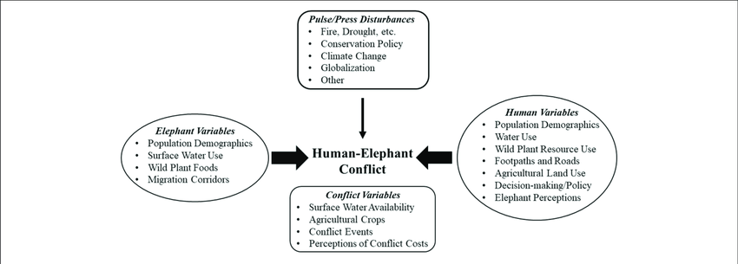

*Figure 1 variables*

Definition of the problem

Human elephant conflict is one of the major unsolved challenges in Sri Lanka. From past few decades to now civilization is in a rapid booming over natural habitats. Sharing the same environment by human communities and elephants have influenced HEC in a large scale.

Asian elephants (*Elephas maximus*) can be found in 13 range of Asian countries in Asia. Elephants possess a long-life span. Their habitats spread over a vast area*.* Some studies show Asian elephant migration extend from 20 km to 50 km. Elephants maximum daily consume of forage is 150 kg and they use more than 190 L of water for their hydration (Shaffer, 2019).

Crop raiding by wild elephants is an unbearable issue. This situation appears under many reasons. As an agronomic country rice is our main consumption of carbohydrate. Because of that, paddy cultivation gains the center attention on agriculture. Paddy is the most attractive crop for wild elephants. Elephants are naturally chaotic consumers. A single giant can crush acres of crops in one night. Farmers struggle day and night to chase elephants away from their fields. Even though these creatures fulfil their desire by consuming and destroying fields eventually. There are recorded cases of raiding within the harvesting seasons and also attacks and property damaging mostly during the night-time. Farmers regarding these giants as a fatal disaster (Santiapillai, 2010).

One of the research shows there were 14,516 records of HEC incidents during 2010-2019. Various immature behaviors of people causing upper level of deaths and injuries caused by HEC. According to the records there were 807 human deaths and 579 of human injuries done by elephants among 2010-2019. The majority of HEC case records were about property damage. There were more than 10,000 cases were recorded under this category. (Prakash, 2020)

While mankind is struggling for the survival beyond HEC unfortunately these mammals become preys on earth. More than2631 elephant deaths were reported in between 2010-2019 due to this national issue. (Prakash, 2020). These uprising reasons remaining a peak level of HEC in Sri Lanka.

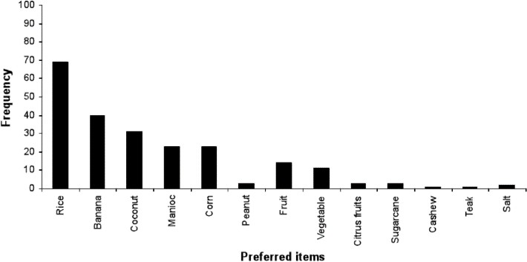

*Figure 2 Most Preferable crops by elephants*

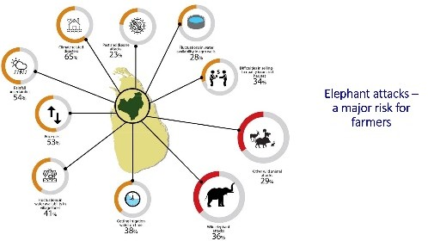

*Figure 3effectiveness of crop raiding*

Project Objectives

Since the decision makers strongly suspect that using an electric fencing is the best option to face the human elephant conflict challenge, the top to bottom assessment of this methodology is of specific significance, especially as far as the productive designation of scarce assets. Some fallbacks of these technologies must be given attention. For instance, electric fences have generally a high introductory foundation cost and likewise they make a separation between rural people and forests nearby.

This examination was started to answer some of these uncertain inquiries regarding the execution of the electric fence. Specifically, it set out to check whether electric fences can stand alone as an answer for the HEC issue. The overall goal of the examination was to research how powerful the electric fence is at relieving the human-elephant struggle. This adequacy was estimated regarding how the fence decrease elephant related episodes that influence the lives and occupations of the rural people. As such, its point was to address the inquiry: "Are electric fences equipped for guaranteeing the endurance of the elephants while improving the social government assistance of the individuals who live in the region of elephant conflicts?"

Our study brings out the specific objectives as follows.

1. To examine and evaluate the efficiency and the effectiveness of the existing methods established in several areas of Sri Lanka to reduce human-elephant conflict.
2. Investigate and analyze draw backs in the existing method by evaluating broadly and propose alternatives available.
3. Finally, the best alternative solution will be designed and will bring up the feasibility study and the prototype testing respectively.

Scope of the project

Different types of technological solutions have been brought up overtime to overcome the boundaries of pre-performed techniques by the farmers or agriculturalists within human territories. Due to the urge of survival and needs, elephants become more curious and find new ways to reach their desires mastering barriers. Electric fences, using Repugnance crops bordering main yields, buffer zones, trenches, string fences and GPS collars are previously used options.

Setbacks of such techniques caused destruction and loss of wealth and lives respectively. This research is motivated by the following fact where the scope of this project is to create an Automatic Alert system for the areas that are prone to human-elephant conflicts to mitigate and control the amount of destruction and danger.

Summary

Sri Lanka owns the third highest among Asian countries regards to the population of wild elephants. These mammals connect strongly with Sri Lankan culture since the historical era. Unfortunately, their survival grounds have limited to 25% of forest area from Sri Lankan grounds. Due to human civilization expanding towards the forest the human-elephant conflicts have driven up more lately. Until recently humans and elephants still have a negative relationship which has always ended with massive destruction or loss of lives. In Sri Lanka the Department of wildlife conservation along with citizens face this situation in many ways to mitigate the conflict situations. It has been recorded more than 15,000 HEC cases reported between a decade and it still continues.

## Chapter 2 - System Analysis

Facts gathering techniques

Relevant to the study, the information was gathered with great difficulty due to the pandemic situations. But we were able to pull out limited number of resources to achieve our requirements.

A questionnaire was carried out as a household survey regarding primary data collection and recorded the information through following inclusions:

* General household information
* Familiarity with smartphones
* Household occupation
* Impression towards elephants
* HE Conflict experiences
* Effectiveness of safety precautions on HEC

The questions were asked through the questionnaire and was filled out by the researches. The collected data was respectively evaluated, and conclusions were done accordingly.

Information about HEC mitigating measures, recent records and incidents, elephant related cases and human interactions were found through several government institutions and officials. Mainly the Department of wildlife conservation’s keep records about human elephant conflicts based on the number of human and elephant deaths, complains about property distractions and conflict. Also, information was gathered from previously done research papers and article resources. These resources can be stated as secondary data collections methods used in this research.

Current system

In Sri Lanka Department of Wildlife Conservation is the fundamental and libel organization for mitigating HEC. DWC follows administrative regions to analyze HEC spreading and implement new prevention methodologies. Hierarchically, Sri Lanka is divided into 9 provinces, 25 districts and 331 of divisional secretariat divisions. As per the records HEC shows a broad spread island wide. HEC occurs in 8 provinces out of 9. 19 districts out of 25 is identified as HEC areas and conflicts were reported among 112 DS divisions and elephant deaths from 131 DS divisions. The strategies of mitigation include traditional implements by local communities and modern methods by state level. (Prakash, 2020)

String fences, tripwire fences, live fences were popular traditional implements to prevents crop raiding by wild elephants. String fences were made by using metal or glass materials. This method generates sounds as an alert message. Tripe wire is also based on an alarm system. Live fences were made by using prickly plants. (Perera, 2009)

Electric fence is the averagely effective prevention procedure which is currently managing by DWC. Electric fencing is much effective with some other mitigation methods. DWC is engaging in developing this method over island wide HEC effected areas. (Perera, 2009)

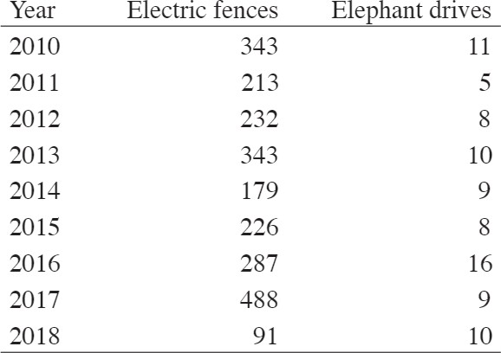*Figure 4Length (in km) of new electric fences erected and number of elephant drives conducted by the DWC annually*

Length (in km) of new electric fences erected and number of elephant drives conducted by the DWC annually. (Prakash, 2020)

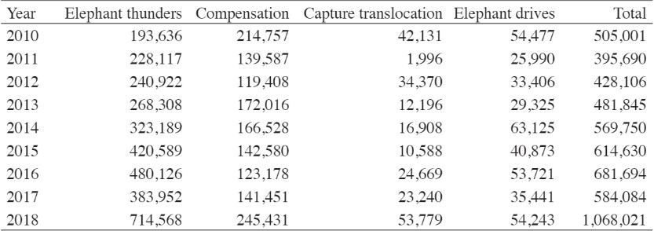

*Figure 5annual expenditure by DWC*

Overall current system use case diagram for the current system

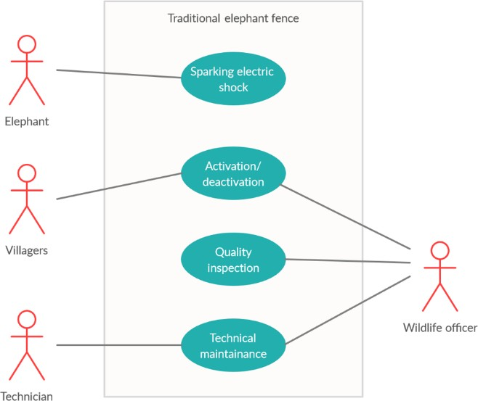

*Figure 6Use case diagram*

Drawbacks of the current system

Electric fencing is the most sensible and technical approach used to manage HEC in Sri Lanka. But electric fence is not an overall successful barrier for HEC. Electric fences are expensive to implement. For example, as estimated cost for a 1 km fencing cost nearly 0.5 M Sri Lankan Rupees. This method is very hard to maintain. Also, elephants become immune to the fencing system. This system arrangement has no methods of a guaranteed alerting.

Summary

The human elephant conflict has a history of over a decade and steps were taken to control and reduce the disastrous outcome. Systems were created and implemented accordingly with a specific motive of reducing the conflict between humans and elephants. Since now and then the Department of wildlife conservation has implemented the current systems with the help of citizens. Current systems such as string fences, live fences using prickly plants, buffer areas and trip wire alarm systems were used. Due to the inefficiency and ineffectiveness of these systems, with time they were failed to control the conflict situations. Among these ineffective solutions they have used one other alternative that was effective averagely. Electric fence system kept elephants from reaching the villages seeking resources. Even though this system qualified to reduce the conflict at the beginning, with time these mammals became immune and improvised back to attack by failing the current systems.

## Chapter 3 - Requirement Specification

Functional requirements

* + The program should be able to detect movements and night visions.
  + It should be able to communicate with the users.
  + The program should be able to recognize the elephants among other animals when in the zero visibility.
  + The program should have the capability of send an alarm by itself to the users of the upcoming danger in real time.
  + Program should have the information about the related authorities and user should be able to inform them through the system.
  + System should have the ability to capture CCTV feed.
  + The system should have the ability to detect the elephant from the CCTV video feed.
  + The system should have the ability to send camera information and detected time to the database.

Non-functional requirements

* + - The program’s interface should be user-friendly.
    - The system should be accessible from anywhere, anytime.
    - The system needs to be up and running 24/7.
    - The program should have secondary power solution, in case of a CEB electricity problem (power cut).
    - The system hardware such as UPS, router, cables should be protected from physical damage.

Performance requirements

* + - Computer processor should be 3 cores or greater than 3 cores for better performance.
    - If using IOT devices, Raspberry pi 4 model B or ram should be 4 GB or grater than 4 GB for better performance.

Security requirements

* + Fire based authentication.
  + CCTV Camera feed will not be uploaded to the database.

Hardware requirements

* + - CCTV Cameras (night vision) and DVR.
    - Cables for the connectivity.
    - Router.
    - Desktop or Mini Computer.
    - Backup power solution (UPS, power generator).
    - Power supply unit.

Summary

Requirement specification collects and formalizes information on the application domain and the expected functions. The input is the collection of business criteria that motivate the production of the application and all the technological, organizational, managerial context information available.

functional requirements define the system does or must not do. In non-functional requirements defines how the system should do it. This does not affect basic functionality of the system.

In performance requirements defines what are the minimum system capabilities of the system must have for run the system. In security requirements defines the security of the data transaction and the authentication. Hardware requirements is the basic hardware components that needs to up and run the system.

## Chapter 4 - Feasibility Study

Economic feasibility

This system is an alert system used by a mobile application. A system like this is very useful for Sri Lanka. Because Elephant-Human conflicts are common in various parts of Sri Lanka.

So, we developed a system for this problem and the costs for that are shown in the

tables.

### Development costs

Estimated cost of Hardware

|  |  |
| --- | --- |
| **Component** | Cost in LKR |
| Computer (system unit, monitor ,mouse, key board) | 40000 |
| UPS | 5000 |
| Internet router 4G | 4000 |
| Night vision camera | 8000 |
| CCTV cable | 3000 |
| Total | 60000 |

Estimate cost for develop this project is 60000 LKR Estimated cost of Prototype

|  |  |
| --- | --- |
| **Component** | Cost in LKR |
| Web camera | 5000 |
| Total | 5000 |

Estimate cost for prototype this project is 5000 LKR

### Operational costs

* Operational costs are the expenses required for the day to day running of the system
* Since we are using free operating system we don’t need to pay for OS.

|  |  |
| --- | --- |
|  | Cost(per annu) LKR |
| Internet service | 1500*12 |
| Electricity bill | 1500*12 |
| Total | 36000 |

Total operational cost is 36000 LKR

* If we have to make repaires like a camera while running this system, it will cost around 8000LKR per camera. Repair to all other devices will be less than this amount.

Considering these Development and Operational costs, those costs are feasible for this project.

Operational feasibility

Power requirement of the system is an issue in a rural area and that can overcome through including a solar panel to the system. Checking the application frequently is not practical and the app has to push notification automatically and having and sound alarm is recommended.

The app must be compatible with any kind of device as it is targeted on general public. Moreover, the targeted group is less exposed to the technical devises and therefore, the app must develop using expandable, easy to update language. Python can be used for the app because it is expandable, easy to update and its supporting to any device.

To secure privacy it is essential to use live feed without uploading or recording camera.

Farmers and villagers are the primary users of the app. So, there will be a lack of language and/or technical knowledge become an issue. User friendly sign languages and simple alarm notifications are used to develop the app. Simplicity can be make easier to adopt the app by targeted audience.

The app must support both platforms iOS and android. So, by using flutter to develop the app will support iOS and android both platforms.

Also, we should update the Realtime database. So, we can use firebase Realtime database to develop the app.

It is a must to run the app in daytime and night-time. So, we must use night vision cameras.

Technical feasibility

In project Elefante we have mainly two components. They are detection and mobile app. For detection we use python-based program. since it’s python we can run our program on pc or mini computers like raspberry pi4 .

we use python 3.6 (stable supported with libraries like keras/TensorFlow )

We can capture video from our camera using open cv library. Using “ cascade Trainer GUI “ we can train our data and create a cascade classifier.

Using cascade Classifier, we can get boundaries of elephants in our video frame. Using open cv we can crop and create new frame according to detected boundaries.

To improve the accuracy of our system we use Keras Applications using ResNet50 with ImageNet weights we can classify our cropped image into Indian elephant, tusker or African elephant. if this classification give us good results we consider there is an elephant in our image frame. For creation of mobile application we use flutter and dart programming language so we can use same codebase for iOS and android. And we use android studio as our integrated development environment for develop our mobile app. for create link between detection and mobile app we use firebase real time database

the main programing languages and tools that associated with our project are - PyCharm(community edition)

Python 3.6 Keras

cascade Trainer GUI /Xml OpenCV

firebase real time database flutter

dart AndroidStudio

these tools are free and technical skills are manageable for group members. All the functions of the system can be implemented. hence this project is technically feasible.

Organizational feasibility

Should provide smartphones for villagers who do not have smartphones and must train them to update the application and to understand the signs of the application. (Basic knowledge is required)

Must provide solutions like solar power for places that do not have electricity. Also, train them to operate the power system.

Officers at the wildlife department should be updated about the notifications from their end and react to the notifications before the users.

The workflow of the wildlife department will not be changed. And officers do not need a specific knowledge.

Outline budget

Estimated cost of Hardware

|  |  |
| --- | --- |
| **Component** | Cost in LKR |
| Computer (system unit, monitor ,mouse, key board) | 40000 |
| UPS | 5000 |
| Internet router 4G | 4000 |
| Night vision camera | 8000 |
| CCTV cable | 3000 |

|  |  |
| --- | --- |
| Total | 60000 |

Estimated cost of Prototype

|  |  |
| --- | --- |
| **Component** | Cost in LKR |
| Web camera | 5000 |
| Total | 5000 |

Chapter 5 - System architecture

Entity Relationship Diagram of the Proposed System

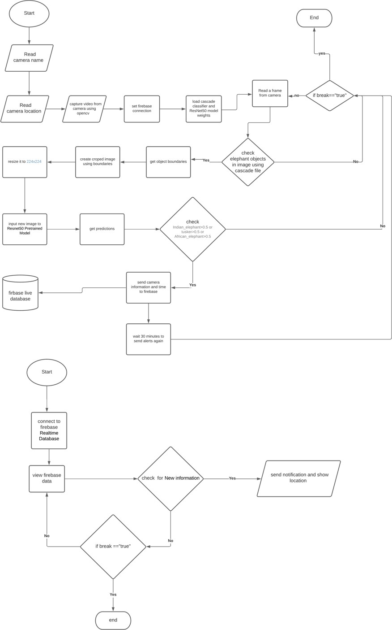

High-level architecture diagram

camera



Elephant detection system

Elephant detection

information

Sender(time location..)

Internet connection

Firebase Realtime database



Push alert notification

Gui for emergency contacts and to provide safety info

Check new alerts

Mobile application

Internet connection

Users (e.g.- drivers)

## Chapter 6 - Development tools and technology

Development methodology

In this project we are using prototype methodology to implement this mobile application which is connected through a detection system. This will overcome system failures. Our prototype demonstrates actual detection over elephants. This will help to gain a proper understanding about this application .

Programming languages and tools.



#### IDE (integrated development environment) software designed specifically for Python programming.

and provide easy way to create python environments. 2)Android Studio

integrated development environment software designed specifically for Android development. 3)Cascade Trainer GUI



Cascade Trainer GUI allow users to train, test, set parameters and improve classifier models. 4)firebase real time database

Firebase Realtime Database use to store and sync data using cloud based NoSQL database 5)flutter-

we can use same codebase for iOS and android if we use flutter 6)Python 3.6

python codes are easy to use, syntaxes are shorter than other languages like c++. easy to import Python Libraries.

stable supported with libraries like keras/TensorFlow.

**Third Party Components and Libraries.**



Keras Applications-

#### deep learning models which available with pre-trained weights.

OpenCV-

Open source computer vision library which is mainly use to object detection, image processing and video capture

Reference - https://keras.io/api/applications/

Discussion

The contention among ranchers and wild elephants, which has raised during the previous fifty years, is currently turning into a significant social just as a policy centered issue in Sri Lanka. The contention is primarily because of the discontinuity and debasement of elephant natural surroundings because of enormous advancement ventures which abused untamed life and biodiversity preservation. There was a 50 percent loss of the woodland cover during the most recent 50 years and, with the expanding rustic populace and shortage of arable grounds, the difficult will turn out to be more extreme later on. Given the way that the greater part of the wild elephants lives external park zones, moderating the contention is seen as the most ideal method of saving jeopardized elephants in Sri Lanka.

The requirement for an alternative arrangement emerged because of the practical limitations in existing solutions used in human elephant conflict. Image capture arrangement is picked as the best option among numerous other dependent on different practical ramifications and requirements. This article reports the consequences of the underlying periods in a continuous examination method call automatic alert system which is an elephant detecting alerting system using a mobile application.

References

Santiapillai, C. &. W. S. &. B. G. &. A. R. &. D. N. &. R. B., 2010. An assessment of the human-elephant conflict in Sri Lanka. *Cey. J. Sci. (Bio. Sci.),* 39(1), pp. 21-33.

Prakash, T. G. S. &. W. A. &. F. P., 2020. Human-Elephant Conflict in Sri Lanka: Patterns and Extent.

*Gajah,* Volume 51, pp. 16-25.

Shaffer, L. J. &. K. K. &. V. D. H. J. &. N. K., 2019. Human-Elephant Conflict: A Review of Current Management Strategies and Future Directions. *Frontiers in Ecology and Evolution.*

Perera, B. M. A. O., 2009. The Human-Elephant Conflict: A Review of Current Status and Mitigation Methods. *Gajaha,* Volume 30, pp. 41-52.

## Team plan and responsibilities

|  |  |  |  |  |  |
| --- | --- | --- | --- | --- | --- |
| Member | Plymouth index no | Name | Tasks carried out | Future plan | Comments by the group leader |
| 1 | 10707016 | M.G.S.C. Bandara | Introduction System Analysis | Explaining the basic idea of  the project | Sufficient contribution |

|  |  |  |  |  |  |
| --- | --- | --- | --- | --- | --- |
| 2 | 10707382 | S.P.L.D.  Sudasinghe | Draw backs of the current system  Use case Diagram | Understanding overall pros and cons of the current system | Sufficient contribution |
| 3 | 10707084 | K.M.S.Jayakody | Requirement specification | Evaluating requirements for further developments  of the system | Sufficient contribution |
| 4 | 10707381 | S.P.L.W.Sudasingha | Development tools and technology High level Architecture diagram Technical  Feasibility | Overcome technical issues to implement suggested system | Sufficient contribution |
| 5 | 10707088 | G. V.A.I.B. Jayawardana | Organizational Feasibility Operational Feasibility Project  Methodology | Observing possibilities from organizational side and  operational side | Sufficient contribution |
| 6 | 10707380 | V.H.R. Soysa | Economic Feasibility Outline Budget ER diagram of the current  system | Managing financial outcomes. | Sufficient contribution |